Name: _____________ Class:_______ Score:____/57
Resources Allowed: Calculator, 1 page of notes (A4 two-sided), Formula sheet

Time: 55mins Marks: 57

- [4 marks]
Match the following equations to the appropriate graph (circle, parabolas, linear)

$$y=-2x$$ |  |  |  | 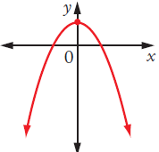
$$y=(x+3)(x-3)$$ |  |  |  | 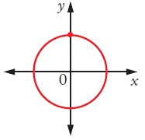
$$y= -2x^{2}+3$$ |  |  |  | 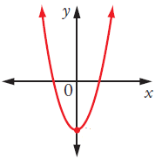
$$y^{2}+x^{2}=3$$ |  |  |  | 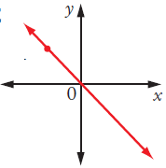

- [3,3 = 6 marks]
Solve the following simultaneously

- $x+y=5$  $$x=y-1$$ | b) $7x+y=128$$$4x-y=15$$

- [2,1= 3marks]
- Sketch the graphs with equations
$y=2x-3$ and 2x + y = 1 accurately on the set of axes provided.
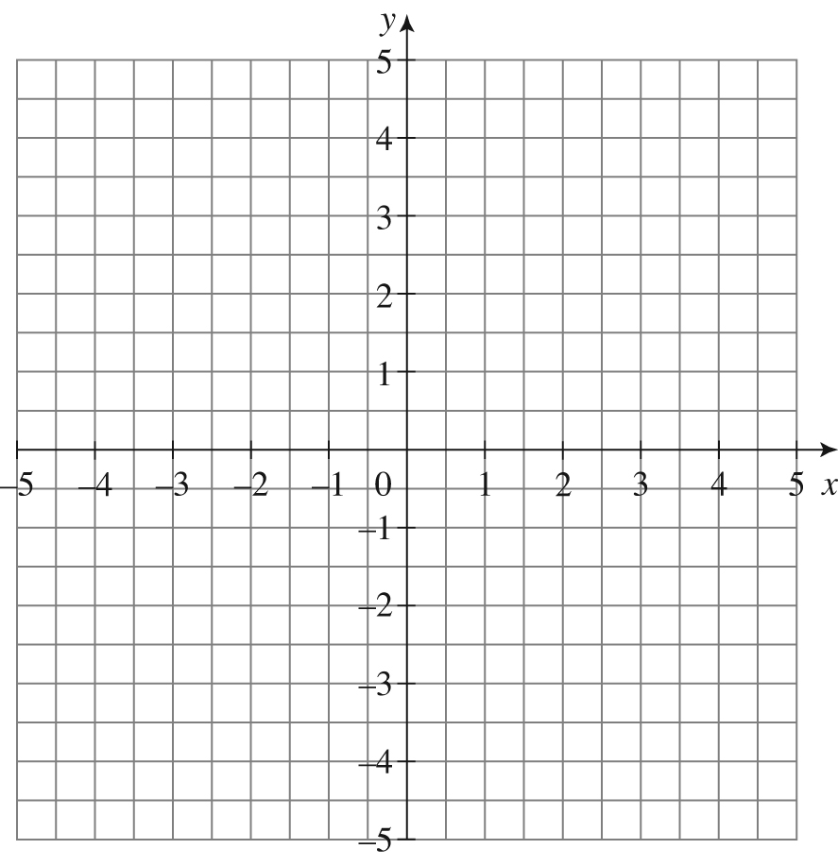
- Solve the equations graphically by stating the x and y values at the point
of intersection.

- [2, 3 = 5 marks]
Entry to an entertainment park costs $150 for one adult and three children. The price of an adult ticket is $30 more than the child’s ticket.

- Write two equations to represent this situation

- Using the two equations from a) solve the equations simultaneously and hence determine the price of an adult ticket and a child ticket.

- [3, 2, 2 = 7 marks]
In reference to the following graph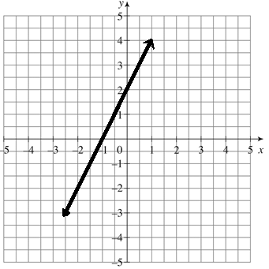
- State the;
i) gradient ii) y-intercept iii) x-intercept

- Write the equation for the line

- Write an equation for a line that is
- Perpendicular ii) Parallel
- [2,2 =4 marks]
Determine the value of missing side using Pythagoras

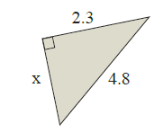 | 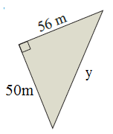

- [3 marks]
A plane flies 50km due East and then 130km due South. How far is the plane from its starting point? (hint: draw a diagram)

- [2, 2, 2 = 6marks]
Use the trigonometric ratios to determine the value of the pronumerals in the following diagrams.

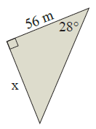 | 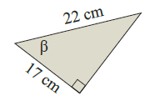 | 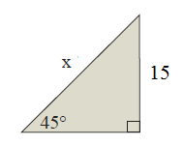

- [3 marks]
From the top of a 200m tower, the angle of depression to a fire is 5 degrees. How far away from the base of the tower is the fire?

- [2,3,3 = 8 marks]
Solve the following Quadratics
- $\left(x+4\right)\left(x-2\right)=0$ | - $x^{2}-2x-15=0$ | - $x^{2}+5x+6=0$

- [1,2,2,2 = 7 marks]
For the quadratic equation

$y=x^{2}+4x+3$

- State the y-intercept | - The x-intercepts | - The turning point
- Sketch the graph on the


End of Test

